The History of Chinese Restaurant in Sunshine Coast and A Note to Celebrate Our 25th Anniversary
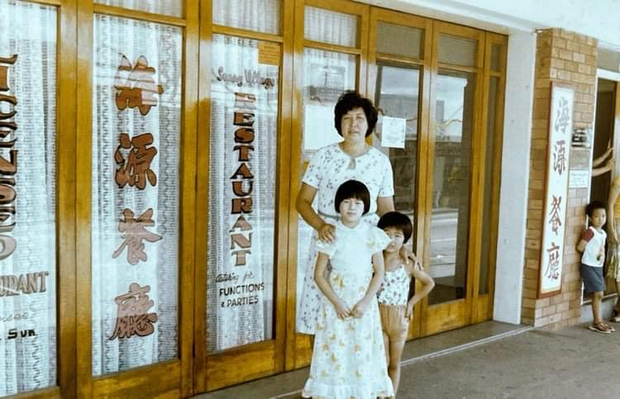
(Kitty and her children at Caloundra)

The motive to start writing this journal begins from the pass away of my aunt in 2022 (Kitty Sun pictured above with her kids in the early 80s in Sunny Village Chinese Restaurant, Bulcock Street, Caloundra) Before she came to Australia, my aunt and her sister ran a popular Hong Kong Café near the old Hong Kong Airport in Kowloon. A few young males from my uncle’s home town in China who were looking for better opportunity in the 60s would have worked there to learn a few skills before hopping into greater adventure in Australia called the New Gold Mountain.

These new migrants came from the city of Zhongshan, named after Sun Yat -Sen, “The father of Modern China” who was a revolutionary and political leader to play an instrumental role in overthrowing the Qing Dynasty in 1911. Therefore, you won’t be surprised that a lot of restaurants were run by the Sun’s in Sunshine Coast between the 60’s to 80s.

My uncle worked in Chinese restaurants in NSW in the early 70s. After nine years, my aunt and her kids finally able to reunited with him in Sydney. As a little child, my impression of Australia was a country far away from Hong Kong and it was also famous for its boomerang, kangaroo and beautiful beaches. Relatives lived in Sydney would bring us Violet Crumble, Hobba Bubba gums and ham as souvenir. We have family running restaurants in San Francisco and Calgary but it was the warm weather that attract my parents to migrate into Australia in the 80s.

As a tale told by Aunty Kitty and Cousin Danny, (the father of Benjamin Law from the TV series Family Law) the beginning of Chinese restaurant in Sunshine Coast started when Peter Sun’s family moved from NSW to the coast in the 60s. Peter Sun helped his dad opened several Hoy Yuen Chinese Restaurants on the Coast. In Chinese, they were all called Hoy Yuen meaning the coastal line. The first Chinese restaurant was open in Bulcock Street, Caloundra named Sunny Village Chinese Restaurant, followed by Maroochy Sands, Coolum Sands and Kawana Sands. Peter was a smart businessman started up the restaurant and then sold it to other Chinese from NSW or new migrants. His business vison made him involved in building the first Asian retirement village, Jeta Gardens in Brisbane.

Cousin Danny bought the Sunny Village Chinese Restaurant with his cousin in the 70’s, then it was sold to my uncle and his brother in the 80’s. As the Chinese community was very small so it wouldn’t be surprised that most of them were related. My uncle worked in the restaurant until his retirement and the restaurant was sold and relocated to a motel in downtown Caloundra. After selling the restaurant to my uncle, Danny opened Sun See Chinese Restaurant, followed by Happy Dragon Chinese restaurant in Maroochydore, a Thai restaurant in Mooloolaba and he also opened the first Asian supermarket at Kawana before moving to Brisbane.

Back to Nambour, the original name of Chef Kim Oriental Restaurant was called Sun’s Chinese. It was opened by Peter Sun’s brother-in-law in the 60’s. He then opened Gympie Hoy Yuen Chinese Restaurant, with the business strategy of running business in the hinterland. He sold his Nambour’s restaurant to Fan Sun who married to an Australian wife, Fan later bought the Gympie Hoy Yuen and worked till he retired. Interestingly, the horror film director Chris Sun based in Sunshine Coast, I wonder if he was related to Fan Sun.

Thomas Yuen was the 3rd owner of the Sun’s Chinese restaurant and he renamed the restaurant to Hoy Yuen Chinese Restaurant matching to its Chinese meaning. Thomas later bought Coolum Sands from Peter Sun. Warrick Chang, Thomas’s son-in-law took over the restaurant until he sold it to us in 1997.

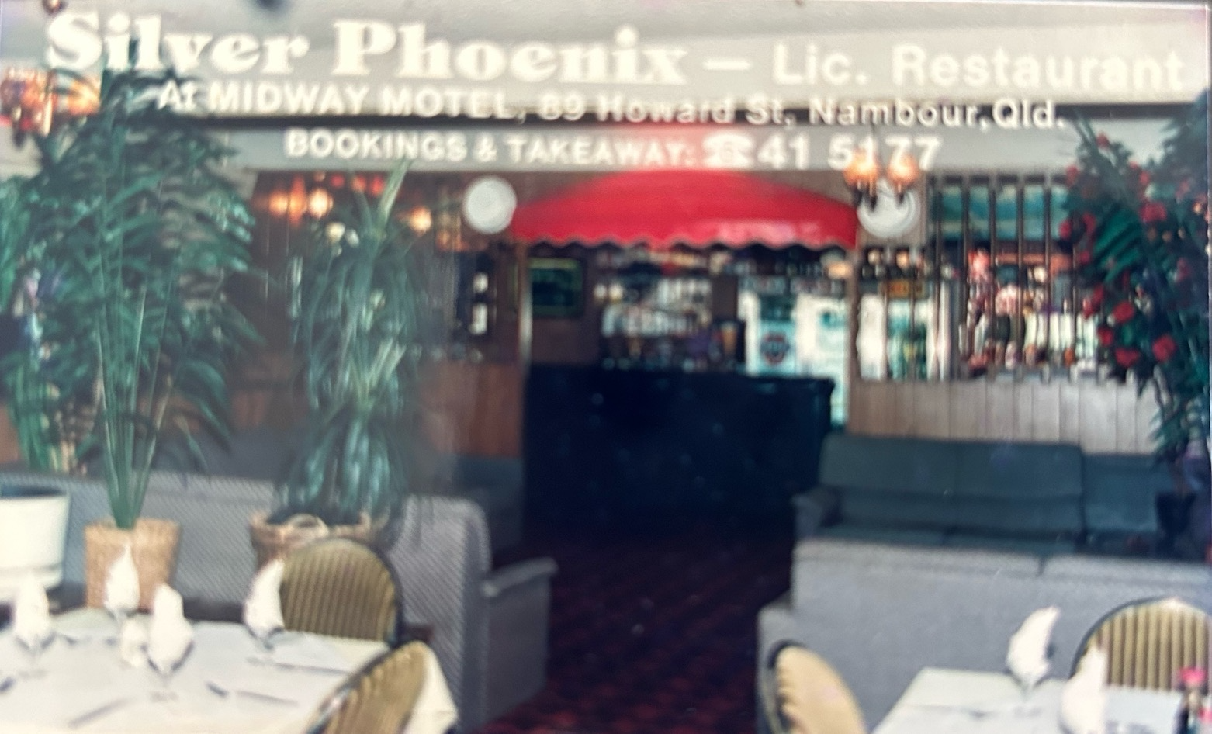
(The bar and Dining Room at the old Silver Phoenix)

My father and my brother-in-law opened Silver Chinese Restaurant in the Midway Motel in Howard Street in 1986. After extension, Silver Phoenix was the biggest restaurant in Nambour, seating for 120 people, fully licensed with a small dance floor. We used to hold a lot of functions and meetings before the renovation of RSL. The old Silver Phoenix’s flame goes down when the motel was sold for the expansion of Nambour Plaza after 18 years of business.
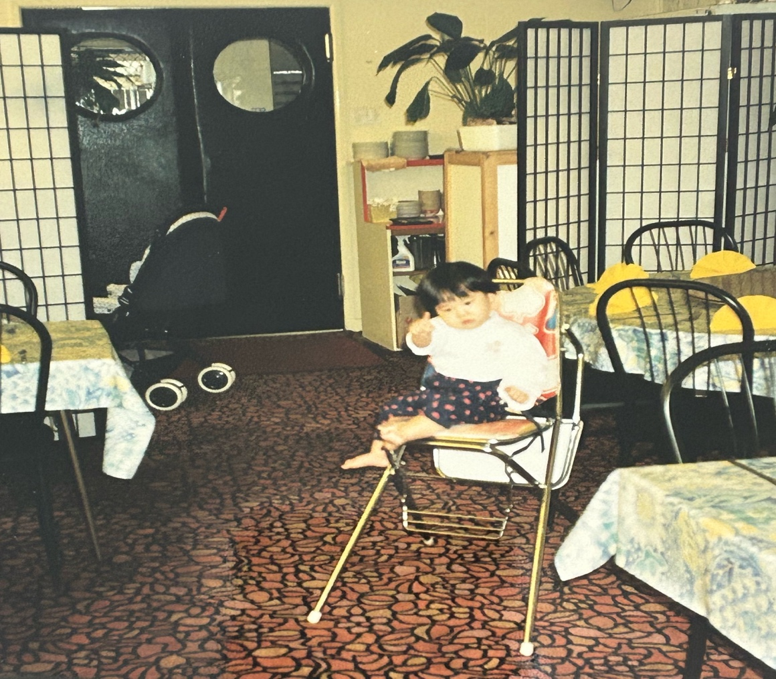
(Our little Director at the opening at Chef Kim)

We left the old Silver Phoenix, bought our own business and renamed Hoy Yuen Chinese to Chef Kim Oriental Restaurant. Hoy Yuen was the first Chinese restaurant did delivery, it had a slogan of “You Ring, We Bring”, however we stopped the deliver services not long after taking over as our business starts blooming. It has been running for 25 years till now. People always say the best Chinese is in Nambour and I hope it remains the same.

Over the years we have seen a lot of closure of Chinese restaurants because there aren’t any successors. Some may turn into other types of restaurants or changed into retail shop, therefore the number of Chinese restaurants serving Cantonese food are getting less and less. On the other hand, we have seen many new comers to serve Asian food such as Thai, Japanese, Korean, Vietnamese and Indian food boosting up the coast hospitality industry. With more migration from mainland China, we also seen Chinese restaurant serving dumplings and bao which was the popular food for the mainland.

Chinese food is still proofed to be popular amongst other types of food after the changing of time. I hope it always bring you some good memories of celebration, weekly take out or just a treat to make you feel happy. So Open Rice and Eat Lah…

Veronica from Chef Kim Nambour, April 2023

